**CHAPTER 1**

**INTRODUCTION**

The plantation drive held in Gudemaranahalli marks a crucial initiative towards improving the local environment and promoting sustainable ecological practices within the community. This well-organized effort was designed to enhance the region’s green cover while encouraging long-term environmental responsibility. The primary goal of the initiative was to plant tree saplings in a systematic manner, ensuring they received the necessary nutrients and care for healthy growth. To achieve this, organizers incorporated natural and organic elements such as compost, coconut dry shells, and manure into the planting process. This strategic approach not only provided the young plants with a strong foundation but also helped improve soil fertility, ensuring sustained growth and development over time. By enriching the soil with essential nutrients, the initiative aimed to create a self-sustaining ecosystem that would contribute to cleaner air, increased biodiversity, and improved soil health.

Beyond the immediate environmental impact, the plantation drive played a significant role in educating the local community about the importance of sustainability and collective environmental efforts. The event was structured to foster teamwork and hands-on learning, allowing participants to gain a deeper understanding of ecological conservation. Volunteers were divided into specialized teams, each assigned specific responsibilities such as planting the saplings, distributing manure, and meticulously documenting the progress of the event. This structured division of labor ensured that the initiative was carried out efficiently while also creating an engaging and interactive experience for everyone involved.

Moreover, the initiative underscored the power of collective action in addressing environmental concerns. By actively involving the community, the plantation drive instilled a sense of responsibility and ownership among participants, inspiring them to adopt more environmentally conscious habits in their daily lives. The event also served as a reminder of the vital role that individuals and communities play in fostering ecological balance. The plantation drive in Gudemaranahalli, therefore, not only brought about immediate improvements in the local environment but also laid the groundwork for continued efforts in sustainability.

**CHAPTER 2**

**OBJECTIVES**

The plantation drive in Gudemaranahalli was primarily focused on enhancing the local environment by expanding green cover and encouraging sustainable agricultural methods. By planting tree saplings and enriching the soil with organic materials like compost, coconut dry shells, and manure, the initiative aimed to improve soil fertility and promote healthy plant growth. This effort not only contributed to maintaining the region’s ecological balance but also supported long-term sustainability by preventing soil erosion, improving air quality, and creating a thriving habitat for local plants and wildlife.

Beyond environmental benefits, the drive also served as an educational opportunity for the community, raising awareness about the importance of conservation and sustainable practices. Residents actively participated in planting and nurturing saplings, gaining firsthand experience in ecological restoration. By organizing participants into specialized teams for planting, nutrient distribution, and event documentation, the initiative emphasized the power of teamwork and collective responsibility in achieving environmental goals.

Additionally, the event played a crucial role in strengthening community involvement in environmental efforts. By engaging local residents at every stage of the project, the drive fostered a sense of shared responsibility toward preserving nature. The successful execution of this initiative set a strong precedent for future community-led environmental programs, **Enhancing the Local Environment**

1. **Expanding Green Cover** – The plantation drive aimed to increase the number of trees in the area, contributing to a greener and healthier environment.
2. **Improving Soil Health** – By using organic materials like compost, coconut dry shells, and manure, the initiative helped enrich the soil, making it more fertile for future plant growth.
3. **Preventing Soil Erosion** – Tree roots help bind the soil, reducing erosion and improving land stability.
4. **Enhancing Air Quality** – The planted saplings will eventually help absorb carbon dioxide and release oxygen, contributing to cleaner air.
5. **Supporting Local Biodiversity** – The new trees will provide food and shelter for local wildlife, helping maintain a balanced ecosystem.

**Promoting Sustainable Agricultural Practices**

1. **Organic Soil Enrichment** – The use of natural fertilizers instead of chemical alternatives promotes sustainable farming methods.
2. **Water Conservation** – Trees improve water retention in the soil, reducing the need for excessive irrigation.
3. **Encouraging Agroforestry** – The plantation effort demonstrated how trees can be integrated into farming systems to benefit both crops and the environment.
4. **Long-Term Carbon Sequestration** – The trees will act as carbon sinks, helping combat climate change by absorbing greenhouse gases.

**Educating the Community**

1. **Raising Awareness** – The event provided a hands-on learning experience about environmental conservation.
2. **Encouraging Responsibility** – Participants learned the importance of nurturing the saplings to ensure their survival.
3. **Demonstrating Practical Techniques** – Community members were trained in proper planting methods, soil management, and tree care.
4. **Showcasing Sustainable Practices** – The event highlighted how composting and organic fertilization can support plant growth naturally.

**Fostering Community Engagement**

1. **Strengthening Social Bonds** – The drive brought people together, promoting teamwork and collaboration.
2. **Encouraging Volunteerism** – Participants gained a sense of fulfillment by contributing to a meaningful cause.
3. **Inspiring Future Initiatives** – The success of this drive set an example for future environmental efforts in the area.
4. **Encouraging Intergenerational Participation** – The event involved people of all ages, ensuring that younger generations develop a habit of environmental stewardship.
5. **Empowering Local Leadership** – Community members took ownership of the initiative, building leadership skills and confidence.

**Long-Term Sustainability and Impact**

1. **Creating a Greener Future** – The trees will grow over time, contributing to long-term environmental improvements.
2. **Encouraging Ongoing Maintenance** – The initiative emphasized the need for regular follow-up care, such as watering and protecting the saplings.
3. **Building a Resilient Ecosystem** – More trees lead to better climate resilience, helping the community adapt to environmental changes.
4. **Setting a Model for Other Communities** – The success of this plantation drive can serve as inspiration for other regions to implement similar projects.

both the environment and the people who depend on it.

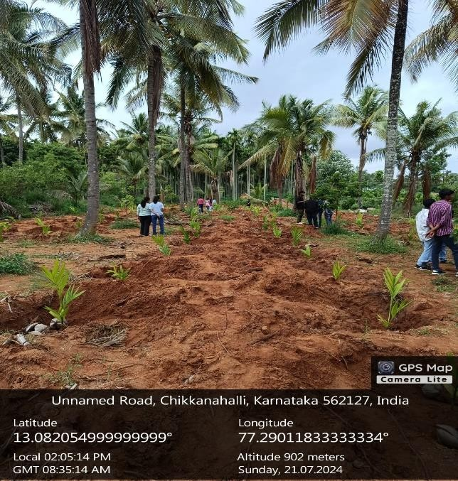

**CHAPTER 3**

**ABOUT THE PLACE**

Gudemaranahalli is a quaint village nestled in the Chikkaballapur district of Karnataka, India. Known for its picturesque rural landscape, the village is deeply rooted in agriculture, serving as a vital contributor to the local economy. It forms a part of the Chikkaballapur taluk and is surrounded by lush farmlands, rolling hills, and the serene beauty characteristic of South India’s countryside.

**Agriculture and Economy**

Farming is the backbone of Gudemaranahalli, with the village primarily cultivating staple crops such as paddy, ragi, maize, and a variety of vegetables. The agricultural cycle dictates the rhythm of daily life, with seasonal harvests playing a crucial role in sustaining livelihoods. Traditional farming methods coexist with modern agricultural practices, ensuring productivity while preserving the region’s agrarian heritage. Many local families are engaged in farming-related occupations, including dairy farming and trade, further reinforcing agriculture as the primary economic driver.

**Cultural Significance and Traditions**

Gudemaranahalli is steeped in Kannada culture, with traditions passed down through generations. Festivals such as **Ugadi (Kannada New Year), Deepavali (Festival of Lights), and Sankranti** are celebrated with great enthusiasm, bringing the community together in vibrant cultural expressions. Local fairs and religious ceremonies add to the festive spirit, offering glimpses of the region’s deep-rooted customs and social harmony. Temples and places of worship play an integral role in daily life, serving as centers for spiritual gatherings and cultural events.

**Infrastructure and Connectivity**

As a rural settlement, Gudemaranahalli’s infrastructure is evolving, with facilities such as roads, schools, and healthcare centers developing gradually. While access to urban conveniences may be limited compared to larger towns and cities, the village maintains essential services to support its residents. Connectivity to nearby urban centers through road networks facilitates trade, education, and healthcare access, ensuring that villagers can benefit from broader economic and social opportunities.

**Natural Beauty and Environment**

The village is surrounded by scenic landscapes, characterized by vast green fields, gently rolling hills, and a peaceful rural atmosphere. The environment offers a retreat from the hustle and bustle of city life, making it an ideal place for those who appreciate nature’s tranquility. The unspoiled charm of Gudemaranahalli highlights the essence of Karnataka’s countryside, where life moves at a slower yet fulfilling pace.

In essence, Gudemaranahalli embodies the spirit of rural Karnataka, where tradition and agriculture form the foundation of daily existence, and nature’s beauty remains an ever-present backdrop to the lives of its people.



**CHAPTER 4**

**CONDUCTION OF THE ACTIVITY**

The plantation drive was carried out in a well-structured manner, divided into distinct phases to ensure efficiency and effectiveness. Each phase was carefully planned to facilitate smooth execution and maximize the success of the initiative.

**1. Preparation Phase**

This phase focused on laying the groundwork to ensure optimal conditions for the saplings.

* **Site Selection and Pit Digging:** Suitable locations were identified for planting the saplings, and pits were dug to the appropriate depth. This step was essential to provide adequate space and a supportive environment for plant growth.
* **Material Transportation:** Necessary resources such as compost, dried coconut shells, and manure were transported to the site. Proper planning and organization were required to ensure all materials were available on time and in the required quantity.

**2. Team Formation and Task Allocation**

To streamline the activities and improve efficiency, participants were divided into specialized teams, each responsible for a specific task:

* **Plantation Team:** Focused on planting the saplings at the right depth while maintaining adequate spacing between them.
* **Manure Distribution Team:** Tasked with applying compost, dried coconut shells, and manure around the saplings to enhance soil quality and provide necessary nutrients.
* **Mulching Team:** Responsible for spreading mulch around the plants to retain soil moisture, suppress weed growth, and improve overall soil health.
* **Media Team:** Documented the entire plantation drive through photographs and videos, helping to spread awareness about the initiative through different media channels.

**3. Implementation Phase**

This phase involved the actual execution of the plantation activities in a systematic manner.

* **Planting and Mulching:** Teams worked together to plant the saplings and cover the soil around them with mulch for added protection.
* **Nutrient Application:** The manure distribution team applied compost and organic materials to enrich the soil, ensuring that each sapling received adequate nourishment.
* **Supervision and Coordination:** Team leaders oversaw the process to maintain efficiency, resolve any issues, and ensure all tasks were completed on schedule.

**Challenges Encountered**

Despite careful planning, several obstacles arose during the plantation drive:

1. **Logistical Challenges:**
   * Transporting materials to the site was difficult, requiring efficient scheduling and resource management.
   * Ensuring sufficient tools and equipment for all participants was another challenge, necessitating careful coordination.
2. **Unfavorable Weather Conditions:**
   * Sudden weather changes, such as heavy rain or extreme heat, disrupted the plantation schedule.
   * Protective measures had to be taken to shield the saplings from harsh environmental conditions.
3. **Team Coordination Issues:**
   * Managing multiple teams simultaneously and ensuring smooth collaboration was complex.
   * Avoiding delays and task overlaps required strong leadership and effective communication.

**CONCLUSION**

The plantation drive in Gudemaranahalli stands as a testament to the power of collective effort and strategic environmental action. Through meticulous planning, teamwork, and sustainable practices, the initiative not only enriched the local ecosystem but also instilled a sense of environmental responsibility among participants. The use of compost, coconut dry shells, and manure ensured that the saplings received adequate nourishment, increasing their chances of long-term survival and growth.

One of the key takeaways from this initiative was the role of community engagement in driving meaningful environmental change. By actively involving individuals in the planting process, distributing nutrients, and documenting the event, the drive fostered awareness and strengthened the bond between people and nature. The challenges faced during execution were met with resilience and collaboration, further emphasizing the importance of determination and adaptability in environmental efforts.

Looking ahead, the true impact of this initiative will be realized through consistent follow-up efforts, including regular maintenance, monitoring of sapling growth, and community-driven activities to sustain the momentum. Encouraging long-term participation and raising awareness about the benefits of afforestation will be essential in ensuring that the saplings grow into thriving trees, contributing to biodiversity, cleaner air, and a healthier ecosystem.

In essence, this plantation drive was more than just an event—it was a step toward long-term environmental stewardship. If sustained and expanded, such initiatives have the potential to create a lasting ecological legacy, benefiting not just the present community but also future generations who will inherit a greener and more sustainable world.

Top of Form

Bottom of Form